**Team 6**



**SQS-USA**

**Enhance Training Web Application for SQS Quality Assurance New Hires**

**Dylan Jenkins**

**Jake Davis**

**Binod Katwal**

**Manni Mashaee**

**Table of Contents**

Introduction………………………………………………………………………………………………2

Project Overview……………………………………………………………………………………….2

Development and Target Environments…………………………………………………….3

System Model……………………………………………………………………………………………3

User Interactions…………………………………………………….…………………………………4

User Scenarios…………………………………………………………………………….…..4

Functional Requirements……………………………………………..……………………………5

Nonfunctional Requirements……………………………………..……………………………..6

Feasibility……………………………………..…………………………………………………………..6

Conclusion…………………………………………………………………………………………………7

Appendices…………………………..……………………………………………………………………8

Database Model……………………………………………………………………………….8

Website Map………………………..………………………………………………………….9

Use-Case Diagram………………..…………………………………………………………..10

**Introduction**

Software Quality Systems(SQS) is interested in building a website to train new employees. The intention is to eventually have an automated site that will train new hires for SQS. Our task for this semester is to implement a skills bank for the employees to place relevant hardware and software skills, a progress bar to continuously update the users/employees as to how far along in the skills bank/registration process they are, and element id tags for any clickable item on the website. Our purpose in this task is to implement these features into their website to assist with the process of creating the website to train their employees. The content that follows in this document further details the scope of this project and specifications/requirements.

**Project Overview**

SQS has tasked us with three key features they would like to have implemented into their website. A skills bank for each user to store their relevant hardware and software skills. We intend to do this with a redesigned registration process. Next is a progress bar which will be affected by how far along in this skills bank/new registration process they are. This should be continuously updated, allowing for forward and backwards progression. Lastly, they wanted us to give each clickable item on the website a unique element id tag in order to assist the automation that will eventually automate the website.

Currently SQS does not have an automated method for training employees. We are assisting in the process of enhancing this training website for SQS. The scope of the entire project is going to be a multi-step process that will continue to be worked on after Team 6 and take time to ultimately implement every feature desired. This will improve their training process upon completion. The scope for Team 6 is to implement the desired features discussed in this document and if we have time there are optional features to implement as well. This typically is not something that can be bought, alas it must be created from the ground up.

**Development and Target Environments**

The software used by previous groups to build and run the website included the traditional LAMP stack: Linux operating system, Apache HTTP Server, MySQL, and PHP. This will still be used, but instead we will use the cross platform version XAMPP. In addition to that, to handle administration of the MySQL database, phpMyAdmin will be used. However the software listed is what we intend to use, this does not mean that other web technologies will not work, provided the requirements are met, and all other settings and paths are correct.

The website will be built on a MAC and PC using MAC OS and Windows 10, but also can be built and ran on any computer/OS capable of downloading and running XAMPP and the other software listed above.

**System Model**

The overall system SQS has provided will change internally more than externally. Team 6 will be enhancing the current registration process but otherwise that is the biggest visual or external change. Additional enhancing will be behind the scenes in the code. Attaching element id tags to any item that may be interacted with as a user on the web application.

As far as the database is concerned we are simply adding two additional VARCHAR’s to the User table in order to save the user's skills to their account. The current system has one page in the resignation process and only a few things are required. The proposed system will have multiple pages in order to register. The first page being the required information. The second, address/mailing information. Third, Software skills and lastly, hardware skills. Only the first page is required, a user may bypass the additional pages by simply continuing to the next page, ignoring additional information questions and ultimately clicking register.

In the appendices section, there are diagrams depicting the Database Model, explaining the relationships between each table and providing information in relation to the design of the database being used. This is followed by the Website Map which depicts the website currently, upon completion of the project the website will not be affected much. It will have additional pages in the sign up or registration process but visually that along with the progress bar will be the major changes to the website. Lastly, is the Use-Case Diagram with shows use cases for a few of the various users that will be accessing the web application.

**User Interaction**

When a new SQS employee first enters the website, they must login or signup. Upon signing up, the user is prompted to enter some information. After or even on the same page as when the user enters their information, there will be a process to obtain a skills bank for them. In accordance with this, there will be a progress bar that will display to the user how far along in this process they are. Below are some User Scenarios that provide a better example of the ideal user interaction.

**User Scenarios**

**Scenario 1:** A skills bank. A place to store each trainee or employees’ skills on their account.

After the trainee or SQS employee has created a valid account. The user should be prompted to enter a process to enter relevant skills by filling out multiple pages of forms and ultimately save them to the user's profile or account. The user should be able navigate backwards and forwards and the information should be retained while moving back and forth. This process should obtain the user's skills and save them to their profile and the database. The skills bank can help to cater to each trainee/employees training.

**Scenario 2:** A progress bar. A place where each trainee or employees will view how far along their progress is in a process.

The trainee or SQS employee after creating an account is prompted to enter the skills bank process. The user answers questions, filling in the appropriate fields, page by page the progress bar updates accordingly, showing how much has been completed and how much is remaining. This should appear during the skills process asking users about their skills and vanish upon completion.

**Scenario 3:** HTML Element ID tags. Tags for each and any item clickable by users.

It would be beneficial to have html element ID tags for each text box, list, menu, or any clickable item on the website. This will assist the automation team that will eventually automate the website. This will provide each clickable item on the website a unique ID tag to differentiate between items.

**Functional Requirements**

SQS has the intentions of this website being the training tool for their employees. With that being the case there are quite a few requirements in order for this to be fully implemented. A typical SQS employee should be able to take all the files provided, set up an Apache server running a MySQL database easily by using one of the various software programs to do so (LAMP, WAMP, XAMPP). From there the employee should be able to follow the README file provided, create the appropriate tables, and run the website from any available web browser.

The user will begin by signing up, the signup process will begin by asking the user for the required information (Name, Email, Password). The user will then be brought to an address information page. Asking for the user's address, email, phone number, etc... This information is not required but highly recommended, the user may choose to fill out the information or continue to the next page. Upon completion of the address information page the user will be brought to a page of questions about the user's software skills. After this there will be a hardware skills page asking about the user's hardware skills.

Again, this information is optional and may be left blank allowing the user to simply register with no information other than the required information on the first page. During the redesigned registration process, the user should be able to navigate backwards and forwards and each page should retain the information filled out. The progress bar should appear during this process and will update according to how far along the user is in the process, also allowing for backwards and forwards navigation and retaining the information on each page, if the user needs to go back a page, the information on the current page is kept unless canceled or cleared by the user.

Then behind the scenes each clickable item will have a unique element id to identify it on the website. This is something that will be beneficial for the automation team that will eventually automate the website. These element IDs will provide a means to differentiate each button, text box, link, and anything else a user can interact with or click on. Upon completion all of these features should integrate seamlessly into the web application as if they have always been there.

**Nonfunctional Requirements**

SQS currently has a web application that ultimately allows a user to connect to an SQS related website that will allow the user to login if already registered otherwise the user must register. Upon clicking one of the three options available, the third option being Home which simply directs you to the home page. The user is directed to sign in with their email and password or if they are registering the user is taken to the registration page where it asks the user for their name, email, password and some additional information if the user chooses to fill it out. After registering the user then has four options. Home, View Profile, Groups and Logout.

On the logged in user's home screen they will now see an option to subscribe to the phone listing. If the user clicks on View Profile, they are taken to a page where they can view their profile and all information regarding their account. From here the user has the option to edit some parts of their profile. If the user clicks Groups, they are directed to a page that simply displays the active groups and any group members pertaining to each group. All this information is stored on an Apache HTTP Server using MySQL and PHP. The information stored in the database is continuously used to store information sent from the website and to display it to a user on the website. SQS’ web application is a training tool used to better their new hires and employees’ skills.

**Feasibility**

The entire Training Web Application that SQS has planned to implement is a large task that will require multiple teams many semesters to ultimately accomplish. The features requested are some of the minor updates to their training web application that are desired. The list is vast and could easily grow to encompass many more features in the future. SQS is aware of students time restraints so they provided us with a list of features they would like to have.

Upon our meeting with SQS we really hammered down three specific features they would like to have implemented which we have already discussed previously. The skills bank, the progress bar and the element id tags. Those were the three features we felt we knew we could accomplish by the end of the semester. With this in mind SQS provided us with a list of seven features they would like but only the ones we discussed were what is required. Everything else on the list is optional and will ultimately be a matter of if we have time to accomplish these tasks.

The other features discussed were to verify that the application can support concurrently logged in users, up to 50 and to implement this functionality if needed. SQS would like a password validation and character limit checks if it was not already implemented. It was also mentioned that they would like to see a multi-tiered menu implemented into their web application and potentially profile pictures available to each user. Again these things are optional but are something that SQS would ultimately like to see implemented into their application eventually.

**Conclusion**

Software Quality System(SQS) is developing a web application which will allow its new and current employees to train and better their skills. SQS is interested in enhancing their current web application used for training. Our task this semester for SQS is to modify the existing web application by updating new features to it. By leveraging SQS, Team 6 will successfully implement a skills bank which will allow users to add relevant skills. A progress bar to indicate how far along in the resignation/information process a user is and element id tags for any item that a user can interact with on the web application. These features discussed previously in this document are some of the many features SQS would like to have implemented into their web application. Any remaining time will be spent attempting to implement one of the other optional features desired.

**Appendices**

**Database Model**

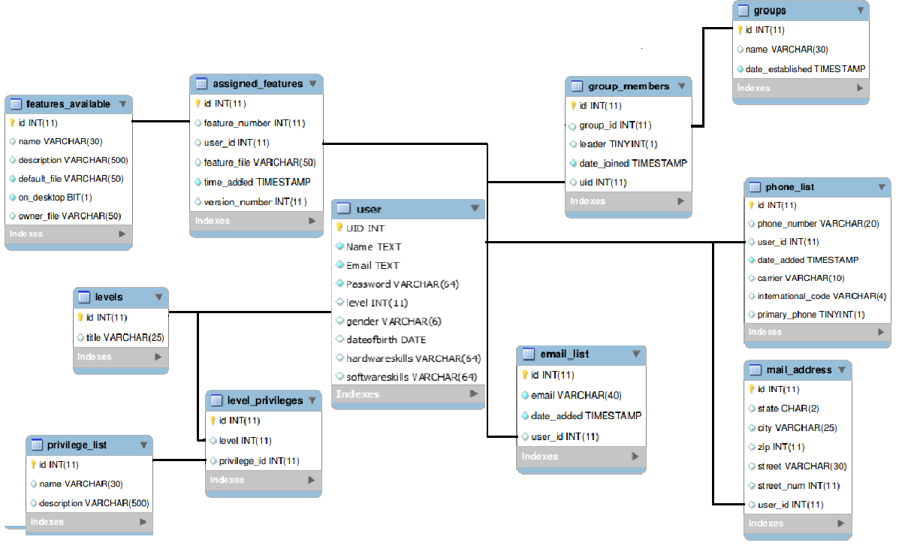

**Website Map**

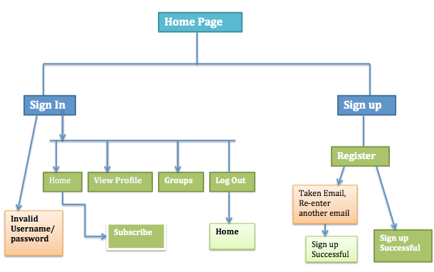

**Use-Case Diagram**